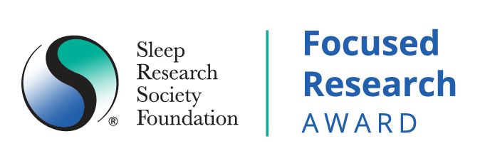
2023 Application
Cardiovascular Outcomes in Narcolepsy
Submission Deadline: Tuesday, January 31, 2023 at 11:59pm CT
SUBMIT ONE PDF FILE WITH ALL CONTENT TO FOUNDATION@SRSNET.ORG.

Required format: Margins: .5”; Font: Arial 11 pt, single spaced; no smaller than Arial 10 pt in figures and tables.
Cover Page
Abstract (250 words)

Date of Application:  Applicant Information  Applicant Name:  Applicant Email Address:  SRS Member Number:  Applicant’s Institution(s)  (Current/All other affiliations within past three years):  Department:  Academic Title:  Terminal Degree(s) and Date(s) conferred:  Grant/financial manager name and email:  Demographic information (optional):  US Based Applicants:  - Do you belong to any of the following race/ethnicity groups: Blacks or African Americans, Hispanics or Latinos, American Indians or Alaska Natives, Native Hawaiians, and other Pacific Islanders: Yes/No/Prefer not to say  - Physical or mental disability: Yes/No/Prefer not to say  - Individual from disadvantaged backgrounds: Yes/No/Prefer not to say |  |  | Applicant Institution(s):  Department:  Academic Title:  Degrees and Dates:  Mentor(s)/Institution(s):

Non-US Based Applicants:
- Feel free to share any demographic information:

Conflict of Interest
The following constitutes a conflict of interest:
- Applicant is employed or contracted by the University of Arizona.
- Applicant is a current collaborator with or within the past three years has published with, collaborated with or has been in a mentoring relationship with the SRSF Honest Broker.
I, hereby, attest that I am not in conflict per the defined COI policy. Insert initials
I am willing to work with the SRSF honest broker for data-analytical methods and approaches as needed during the funding period. Insert initials

PI/Applicant Name:
A. Research Plan: The plan should describe the overall strategy, methodology, and analyses to be used to accomplish the specific aims of the project. Discuss potential problems, alternative strategies, and benchmarks for success anticipated to achieve the aims. Additional criteria to be included are the data-security plan, and prior track record of impactful publications.(7 Page limit)
The plan should include a rationale for the work, an explicit description of how the research will be accomplished, analyzed, and interpreted.

Specific Aims (1 page limit)

Significance

Innovation

Preliminary Data

Approach

Anticipated Results and Alternative Approaches

B. Budget - Not included in page limit:

Budget & Budget Justification: annual budget up to $400,000 for one year. No indirect costs may be requested, and a letter from your institution agreeing to the no indirect costs rule is required. Fringe rates can be applied as per institutional policies and rates.

Funds can be used to purchase access to the datasets (specifically, IBM-Truven Health Analytics Data sets [Merative™ MarketScan®] or Optum Claims Data); access to high performance computing laboratories in the absence of such facilities in the applicant’s institution is an allowable cost, salaries to cover sufficient effort for a senior statistician and database manager/coder in addition to the investigative team; travel costs are allowed but need to be reasonable (< $5,000 total).

Submit budget and budget justification based on the following criteria:

NO INDIRECT COSTS MAY BE REQUESTED | Amount
Personnel:

Fringe:

Equipment/Data sets:

Supplies:

Travel (allowed only if essential to carry out project):

Other Expenses:

Total Direct Costs: | $

C. Facilities and Resources – (1 page limit) Specify equipment, materials, office/lab space, etc. available to applicant and relevant to intended research.

D. Timeline for Project (Milestones/Dates).

  - 0 days: Approval or exempt status determination by Institutional Review Board must be obtained during the Just-in-Time period (April 2023-June 2023). Earlier start date is feasible. 50% of award will be issued to successful applicant upon execution of the contract.
  - 60 days: Evidence of successful execution of Data Use Agreement with 3rd party or attestation that investigators are in possession of datasets obtained previously.
  - 90 days: Attestation of successfully extracting and cleaning dataset with all required variables for analyses.
  - 120 days: Attestation of ongoing discussions with SRSF honest broker for data-analytical approaches (if needed). Applicant team will receive formal introduction to SRSF honest broker upon award notice in April/May 2023.
  - 180 days: Interim progress report update to SRSF regarding progress related to data extraction, data analysis, project timelines, and deliverables. 25% of the total award will be distributed upon satisfactory interim progress report.
  - 240 days: Evidence of submission of a manuscript to a peer-reviewed journal.
  - 365 days: Final report with status of scientific publications and presentations. The final 25% of the award will be distributed upon acceptance of the final report.

What is your plan to meet these milestones (1-page limit)?

E. Biosketches (Biosketches for key personnel (5-page NIH format)

Please attach NIH Biosketch for PI and team using latest NIH Biosketch format.
https://grants.nih.gov/grants/forms/biosketch.htm

NOTE: The Biographical Sketch may not exceed FIVE pages for each investigator.

