Sleep Research Society
Advocacy Successes Summary
June 24, 2022
Prepared By: Dale Dirks and Dane Christiansen, Health & Medicine Counsel

The Sleep Research Society (SRS) continues to lead efforts to advocate for additional funding for federal sleep research activities. Coordinated ongoing congressional and administration outreach coupled with strong funding applications have led to significant enhancement of sleep research portfolios over recent years. SRS has also begun successful efforts to reinvigorate public health activities on sleep disorders and healthy sleep. Below, please find a recent summary of major advocacy initiatives.

- Over recent years, the sleep research portfolio at the National Institutes of Health (NIH) has more than doubled in size from $233 million in FY 2014 to more than $500 million today. Over the same period, the NIH budget has grown by about 35% and the sleep increase outpaces nearly every other condition-specific portfolio.

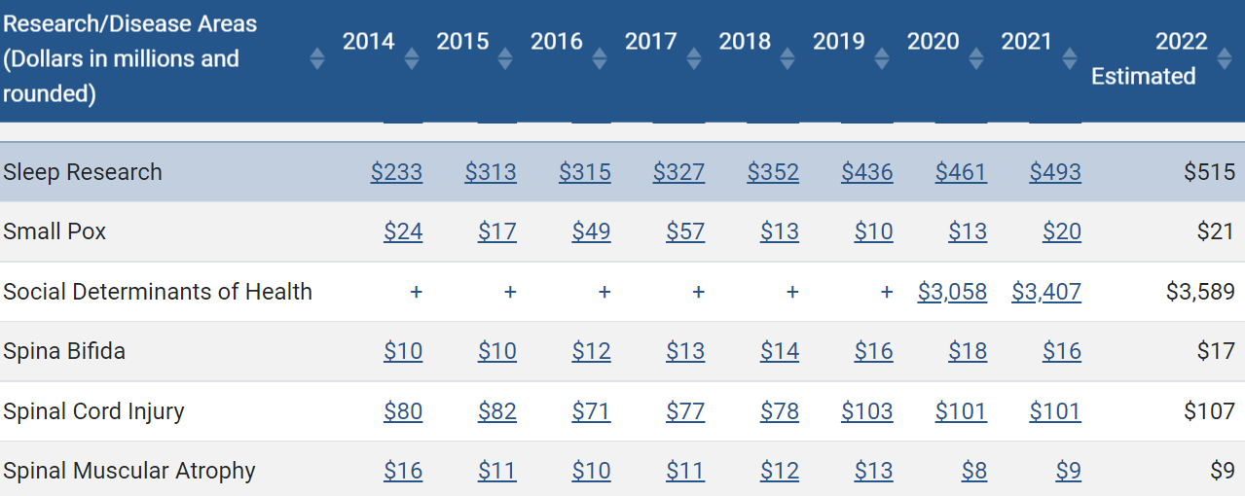

https://report.nih.gov/funding/categorical-spending#/

- For FY 2021, SRS led community efforts to establish the Chronic Disease Education and Awareness (CDEA) Program and the Centers for Disease Control and Prevention with an initial investment of $1.5 million. This program provides cooperative agreement to stakeholder organizations for public health work in condition specific areas. The initial round of funding supported four three-year cooperative agreements, including an initiative for obstructive sleep apnea. Congress then doubled funding for this program to $3 million for FY 2022.

- Congress directs medical research led by the Department of Defense (DoD) through the Peer-Reviewed Medical Research Program and its annual list of conditions deemed eligible for study. Sleep was included in the first-ever eligible conditions list and has been eligible to participate in the program ever since, leading to the DoD becoming a major catalyst of sleep research. This program was initially supported at $20 million for the eligible conditions to compete for but has grown to $370 million today.

- SRS continues to lead efforts to bolster research activities through the VA’s medical and prosthetic research program. That program has grown over time to nearly $1 billion annually today (and sleep specific collaborations in the areas of fatigue, PTSD, and mental health).

- As a result of community advocacy, Congress includes instructions and recommendations with research and public health funding each year. Below, please find the most recent congressional language on sleep from the FY 2022 appropriations process.

Sleep Disorders.—The Committee notes the leadership of NINDS in advancing research into underrepresented sleep disorders, such as narcolepsy, restless legs syndrome, and Kleine Levin Syndrome. The Committee encourages NINDS to bolster these activities and review the state of the science around sleep disorders to better advance initiatives that advance scientific understanding of specific sleep disorders impacting patients.

Sleep and Circadian-Dependent Mechanisms Contributing to Opioid Use Disorder.—The Committee notes NIDA’s continued support in research to better understand opioid use disorder and urges engagement with stakeholders to examine contributing factors, including sleep and circadian-dependent mechanisms.

National Center on Sleep Disorders Research [NCSDR].—The Committee notes the appointment of a new NCSDR Director as well as the release of a long overdue strategic plan. The Committee requests the Center provide an update in the fiscal year 2023 CJ on plans and stakeholder collaboration efforts, to effectively advance the Center’s mission. This update may include information on the Center’s work to promote cross-agency collaboration, participate in emerging efforts (such as addressing health disparities), and lead a variety of impactful research projects.

The funding in the Combat Readiness Medical Research program should be used for research and development of rapidly deployable, all-in-one acute and chronic wound care therapy engineered to address complex trauma and start tissue regeneration; repairing or restoring damaged or missing genitourinary organs and tissue; freeze dried plasma and platelets; portable neurological devices in support of mild traumatic brain injury assessment; hand-held detection devices for traumatic brain injury; head trauma injury; ruggedized oxygen generation systems; medical simulation technology; sleep disorders; eating disorders; extracorporeal life support; myalgic encephalomyelitis/chronic fatigue syndrome; regenerative medicine; sarcoidosis; valley fever; complementary health measures to accelerate return to duty; highly infectious disease treatment and transport; preventing and relieving service-related arthritis; and telemedicine.

Peer-Reviewed Medical Research Program.—The Committee recommends $370,000,000 for the Peer-Reviewed Medical Research Program. The Committee directs the Secretary of Defense, in conjunction with the Service Surgeons General, to select medical research projects of clear scientific merit and direct relevance to military health. Research areas considered under this funding are restricted to: Alzheimer’s, arthritis, autism, burn pit exposure, cardiomyopathy, congenital heart disease, diabetes, Duchenne muscular dystrophy, dystonia, eating disorders, emerging viral diseases, endometriosis, epidermolysis bullosa, familial hypercholesterolemia, fibrous dysplasia, focal segmental glomerulosclerosis, food allergies, Fragile X, frontotemporal degeneration, Guillain-Barre syndrome, gulf war illness, hemorrhage control, hepatitis B, hydrocephalus, hypercholesterolemia, hypertension, inflammatory bowel diseases, interstitial cystitis, lupus, malaria, metals toxicology, mitochondrial disease, multiple sclerosis, myalgic encephalomyelitis/chronic fatigue syndrome, myeloma, myotonic dystrophy, nephrotic syndrome, neurofibromatosis, non-opioid therapy for pain management, nutrition optimization, Parkinson’s, pathogen-inactivated blood products, peripheral neuropathy, plant-based vaccines, platelet like cell production, polycystic kidney disease, pressure ulcers, pulmonary fibrosis, reconstructive transplantation, respiratory health, Rett syndrome, rheumatoid arthritis, sleep disorders and restriction, suicide prevention, sustained release drug delivery, tick-borne diseases, trauma, tuberous sclerosis complex, vision, vascular malformations, and women’s heart disease. The Committee emphasizes that the additional funding provided under the Peer-Reviewed Medical Research Program shall be devoted only to the purposes listed above.

