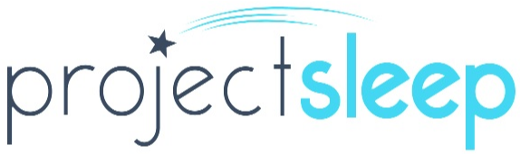

LEGISLATIVE AGENDA
117th Congress, 2nd Session

About the Sleep Research Society
The Sleep Research Society (SRS) was established in 1961 by a group of scientists who shared a common goal to foster scientific investigations on all aspects of sleep and sleep disorders. Since that time, SRS has grown into a professional society comprising over 1,300 researchers nationwide. From promising trainees to accomplished senior level investigators, sleep research has expanded into areas such as psychology, neuroanatomy, pharmacology, cardiology, immunology, metabolism, genomics, and healthy living. SRS recognizes the importance of educating the public about the connection between sleep and health outcomes. SRS promotes training and education in sleep research, public awareness, and evidence-based policy, in addition to hosting forums for the exchange of scientific knowledge pertaining to sleep and circadian rhythms.

About Project Sleep
Project Sleep is a 501(c)(3) non-profit organization raising awareness about sleep health and sleep disorders by working with affected individuals and families across the country. Believing in the value of sleep, Project Sleep aims to improve public health by educating individuals and policymakers about the importance of sleep health and sleep disorders. Project Sleep will educate and empower individuals using events, campaigns and programs to bring people together and talk about sleep as a pillar of health.

FY 2023 Funding Recommendations
- The sleep community joins the broader public health community in requesting $11 billion in overall funding for the Centers for Disease Control and Prevention (CDC), an increase of $2.55 billion, to advance professional education, public awareness, and surveillance activities.
- Please provide the CDC Chronic Disease Education and Awareness Program with $6 million, an increase of $3 million over FY 2022, to facilitate additional cooperative agreements to advance timely public health efforts with community stakeholders.

- The sleep community joins the broader research community in requesting $49 billion in discretionary funding for the National Institutes of Health (NIH), an increase of $3.5 billion over FY 2022. Sleep impacts nearly every system of the body and various disease processes, please provide proportional funding increases for all NIH Institutes and Centers to further support sleep, circadian, and sleep disorders research activities.
- Please provide the Advanced Research Projects Agency for Health (ARPA-H) with a meaningful funding increase above the discretionary increase for NIH to properly implement this important and potentially impactful initiative.
- Please support emerging and ongoing diversity, equity, and inclusion activities focused on addressing health disparities and promoting health equity.

- Please provide the Department of Defense (DoD) Peer-Reviewed Medical Research Program with a meaningful funding increase and continue to include “sleep disorders and restriction” on the annual list of conditions deemed eligible for study.

- Please provide the VA Medical and Prosthetic Research Program with $980 million, an increase of $98 million over FY 2022 to enhance support for critical research projects.

